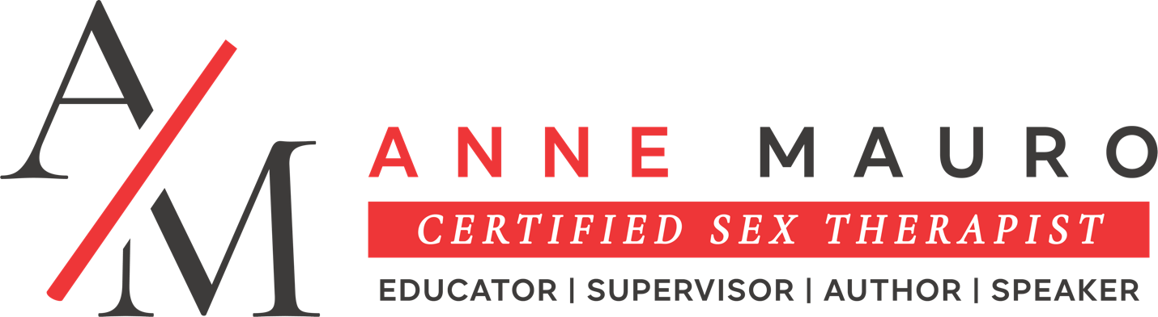
BIO
Anne Mauro, LMFT, DHS, CSE, CST-S

Short bio:
Anne Mauro, LMFT, DHS, CSE, CST-S is a Licensed Relationship therapist, AASECT Certified sex therapist, educator, and supervisor. She invites clients to explore their sexuality with confidence, curiosity, and a renewed sense of connection.

Medium bio:
Anne Mauro is a Licensed Couples and Family therapist, American Association of Sexuality Educators, Counselors, and Therapist (AASECT) certified sex therapist, sexuality educator, sex therapy supervisor, and American Association of Marriage and Family Therapy (AAMFT) clinical supervisor. Her private practice is nestled in the interwebs on the unceded territory of the Coast Salish peoples in Washington State. She has two publications: More Than Ebony and Ivory: Complexities of sex therapy with interracial couples, can be found in An Intersectional Approach to Sex Therapy: Centering the lives of indigenous, racialized, and people of color and The Colonization of Black Sexualities: A clinical guide to relearning and healing. Anne is in continued service to the sexuality community by serving as the AASECT Western Representative to the Nominating Committee and the Membership Steering Committee.

Long bio:
Anne Mauro is a bi-racial Black, multi-cultural, cis queer femme, woman, born and raised in the Pacific Northwest on the unceded Coast Salish Territory. She is a Washington State Licensed Marriage and Family Therapist (LMFT), an AASECT (American Association of Sexuality Educators, Counselors, and Therapists) Certified Sex Therapist (CST), Certified Sexuality Educator (CSE), and Sex Therapy Supervisor (CST-S). Anne is also an American Association for Marriage and Family Therapy (AAMFT) Clinical Supervisor. Her private practice, Mending Connections, PLLC, is nested in New Tacoma and the interwebs, enabling her to work with clients, students, and supervisees across diverse locations, like Qatar, Dubai, China, and Australia, while she remains rooted in the Pacific Northwest. In her clinical work, Anne specializes in sex therapy with adults, helping individuals and couples explore sexuality, enhance relational satisfaction, and reconnect with their erotic potential.
Anne is deeply committed to education and supervision. She teaches in graduate and post-graduate sexuality certificate programs, mentoring clinicians to become liberatory sex therapists. She provides supervision for therapists pursuing AASECT sex therapy and AAMFT certification She has created and taught courses such as Colonization and Sex, as well as co-creating the Beyond Settler Sex Sexual Attitude Reassessment (SAR). Through her teaching and supervision, Anne equips therapists to engage with sexuality in an anti-colonial, inclusive, and affirming lens.
Her publications include More Than Ebony and Ivory: Complexities of Sex Therapy with Interracial Couples, featured in An Intersectional Approach to Sex Therapy: Centering the Lives of Indigenous, Racialized, and People of Color, and The Colonization of Black Sexualities: A Clinical Guide to Relearning and Healing. Her work explores how race, culture, and power intersect with sexuality, highlighting complex dynamics in relationships and therapeutic work.
In addition to her clinical and educational work, Anne actively contributes to the professional community. She has been an AASECT member since 2011 and has volunteered since 2017, serving on the Ethics Advisory Committee and the Awards Committee (chairing one term). She currently serves as the Western Representative to both the Nominating Committee and the Membership Steering Committee, and participates in the AASECT BIPOC Special Interest Group. Through these roles, Anne supports and mentors other professionals, fostering equity, inclusivity, and growth in the field of sex therapy and sexuality education.
Anne’s passion for sexuality began early in life. She started studying human sexuality in 1998 during her undergraduate studies, combining courses in Human Sexuality and Psychology. Initially drawn to forensic psychology, she realized her true calling was to enhance the lives of living people—helping them explore intimacy, erotic connection, and relational satisfaction. She became the first person in Tacoma to earn certification as both an AASECT Sex Therapist and Sexuality Educator and remains one of very few women of color practicing at this intersection in Washington State.
Outside of her professional work, she is a mother, pet caretaker, and lover of plants, trees, and the outdoors. She enjoys motorcycle rides along the coast and exploring the natural beauty of the world. Anne’s personal values of curiosity, mindfulness, and connection inform her approach to therapy, supervision, and teaching.
Anne believes sexuality is central to human embodiment. In all her work—with clients, students, and supervisees—she creates affirming spaces for exploration, healing, and growth. Her approach is grounded in sex-positive values and an anti-colonial framework, always honoring the whole person, their lived experiences, and the cultural and social contexts that shape them.

